PROJECT REPORT
Women’s Clothing: Trends and Analysis
in the Fashion Industry
Categorical Variable Encoding and High-Cardinality Management
Task Perform one-hot encoding for categorical variables while controlling high-cardinality categories through target encoding, frequency-based binning, and dimensionality reduction.

1. Executive Summary
This project transformed categorical variables in a women’s clothing review dataset into machine-learning-ready numerical features. The workflow combined one-hot encoding, frequency-based rare-category binning, leakage-safe target encoding, frequency encoding, and Truncated Singular Value Decomposition (SVD). The design goal was to prevent feature explosion while retaining useful information and maintaining interpretability.
The dataset contained 23,486 reviews and 11 original columns. Low-cardinality variables were one-hot encoded, rare class labels were grouped using a dynamic 0.5% threshold, and the 1,206-value Clothing ID field was compressed into two meaningful features. A dimensionality-reduction alternative was also tested. The final feature matrix contained 36 model features, with no missing values, no text data types, and no duplicate feature names.
Key outcome A naive approach would create approximately 1,238 categorical features. The selected strategy reduced this to 33 categorical features—about a 97% reduction—without deleting any records.

2. Problem Statement
Machine-learning algorithms require numerical input, but the dataset includes categorical product and organizational attributes. Direct one-hot encoding is appropriate for variables with few categories; however, applying it to a product identifier with 1,206 unique values produces a wide, sparse feature matrix. Such feature explosion increases memory use, slows model training, and can encourage overfitting.
The task therefore required a hybrid encoding strategy: simple one-hot encoding where safe, frequency-based grouping for rare labels, supervised target encoding for high-cardinality categories, and dimensionality reduction as an alternative compression technique.

3. Objectives
Objective | Expected outcome
Identify categorical variables | Separate low-, medium-, and high-cardinality fields.
Apply appropriate encoding | Use one-hot encoding only where the generated width remains manageable.
Control rare labels | Combine statistically small categories without dropping records.
Prevent target leakage | Generate target-encoded training values with out-of-fold computation.
Compare compression methods | Assess frequency encoding, target encoding, and Truncated SVD.
Produce reusable outputs | Export the encoded dataset, mappings, and validation reports.

4. Dataset Description
Property | Value
Number of records | 23,486
Original columns | 11
Duplicate rows | 0
Target variable | Recommended IND
Target classes | 0 = not recommended; 1 = recommended
Text columns | Title and Review Text
High-cardinality identifier | Clothing ID (1,206 unique values)

4.1 Initial Data Preparation
The number column was removed because it represented only a row index. Recommended IND was separated as the target. Missing values in Division Name, Department Name, and Class Name were replaced with an explicit Unknown label, preserving all observations and making the missing state interpretable. Clothing ID was converted from integer storage to categorical string form because it identifies a product rather than measuring a numeric quantity.
Title and Review Text were excluded from categorical encoding. Their very high uniqueness reflects unstructured language, so treating them as nominal categories would generate thousands of weak, mostly single-use features. These fields are better handled later through natural-language-processing techniques.

4.2 Cardinality Assessment
Column | Unique categories | Selected treatment
Division Name | 4 including Unknown | One-hot encoding
Department Name | 7 including Unknown | One-hot encoding
Class Name | 21 including Unknown | Rare binning + one-hot encoding
Clothing ID | 1,206 | Frequency encoding + target encoding
Title | Approximately 13,994 | Excluded as unstructured text
Review Text | Approximately 22,635 | Excluded as unstructured text

5. Methodology
The encoding pipeline used cardinality as the routing criterion. Columns with at most 10 categories were treated as low-cardinality. Columns with 11–30 categories were treated as medium-cardinality and checked for rare labels before one-hot encoding. Columns above 30 categories were treated as high-cardinality and routed to compact encoders.

6. Encoding Implementation

6.1 Frequency-Based Rare-Category Binning
A dynamic minimum-frequency threshold was calculated as the larger of 10 records or 0.5% of the dataset. For 23,486 records, the threshold was 118. Categories below this threshold were grouped under Rare, while Unknown was protected as a separate missing-information label.
Original class | Frequency | Replacement
Casual bottoms | 2 | Rare
Chemises | 1 | Rare

6.2 One-Hot Encoding
Division Name, Department Name, and the binned Class Name were encoded into binary indicator columns. The encoder was configured to ignore unseen categories during future transformation rather than failing. An 8-bit integer data type was selected to reduce memory consumption. These three source variables generated approximately 31 transparent binary features.

6.3 Frequency Encoding
Each Clothing ID was mapped to its normalized occurrence frequency: the product’s record count divided by 23,486. This created one compact feature, Clothing ID Frequency. The value remains directly interpretable as product prevalence within the dataset.

6.4 Leakage-Safe Target Encoding
Each Clothing ID was also represented by a smoothed recommendation tendency. A five-fold StratifiedKFold procedure generated out-of-fold values, ensuring that a row’s own target did not directly determine its encoded feature. Within every training fold, category means were blended with the fold-level global recommendation rate using a smoothing strength of 20.
Target-encoding formula Smoothed value = (category count × category mean + 20 × global mean) ÷ (category count + 20). Smoothing pulls unreliable low-count categories toward the overall recommendation rate.

7. Dimensionality Reduction
To evaluate an alternative strategy, Clothing ID was one-hot encoded into a sparse matrix and compressed using Truncated SVD. This technique is suitable for sparse categorical matrices because it does not require centering the data. The 1,206 one-hot product features were reduced to 20 latent components, eliminating 1,186 explicit columns.
An interpretation report recorded the five product indicators with the largest absolute loading on each component. Nevertheless, latent components are less directly understandable than frequency and target-encoded values. SVD was therefore retained as a tested comparison rather than selected for the final interpretable dataset.

8. Technique Comparison and Selection
Technique | Features | Interpretability | Final selection
Direct Clothing ID one-hot | 1,206 | High per column; excessive width | No
Frequency encoding | 1 | High: product prevalence | Yes
Target encoding | 1 | High: smoothed recommendation tendency | Yes
Truncated SVD | 20 | Medium: latent component loadings | No

8.1 Final Feature Composition
Feature group | Count
Original numerical variables | 3
One-hot features | Approximately 31
Frequency-encoded feature | 1
Target-encoded feature | 1
Total model features | 36
Target column | 1
Final dataset columns | 37

9. Results and Validation
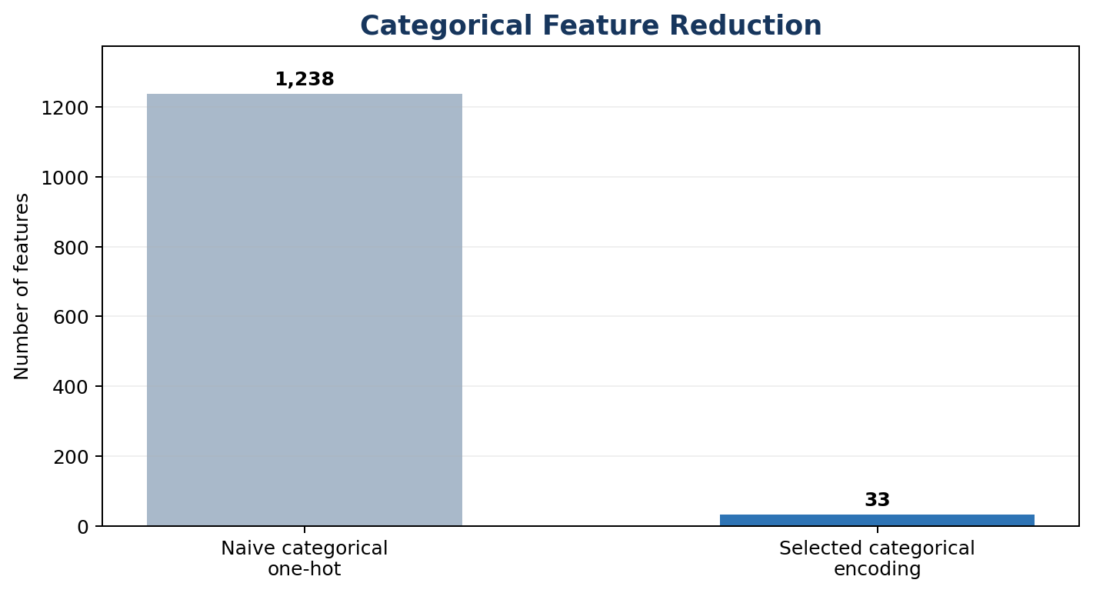
Figure 1. Reduction in categorical feature count after strategy selection
Validation check | Result
Rows preserved | 23,486 of 23,486
Missing values in final encoded data | 0
Object/string features remaining | 0
Duplicate feature names | 0
Final model features | 36
Final columns including target | 37
High-cardinality one-hot columns avoided | 1,206

9.1 Interpretation
The selected pipeline reduced the categorical representation from approximately 1,238 naive one-hot columns to 33 encoded categorical features. This is a reduction of about 97%, while all rows and the information needed to interpret product prevalence and recommendation tendency were retained. The final output is fully numerical and ready for downstream machine-learning workflows.

10. Exported Deliverables
Output file | Purpose
womens_clothing_encoded_dataset.csv | Final machine-learning-ready dataset
categorical_cardinality_report.csv | Cardinality and strategy audit
encoding_technique_comparison.csv | Method comparison and final decision
rare_category_binning_report.csv | Rare-category replacements
clothing_id_frequency_mapping.csv | Frequency lookup by product
clothing_id_target_encoding_mapping.csv | Smoothed target lookup by product
one_hot_feature_report.csv | Generated binary feature names
svd_component_interpretation.csv | Top loadings for latent components
encoding_validation_report.csv | Final quality checks

11. Conclusion
The task was completed successfully through a hybrid categorical-encoding pipeline. One-hot encoding was reserved for variables with manageable cardinality, rare labels were consolidated using a data-dependent frequency threshold, and Clothing ID was transformed using two compact, interpretable features. Five-fold out-of-fold target encoding and smoothing reduced leakage and overfitting risk. Truncated SVD demonstrated an additional dimensionality-reduction option but was not selected because its components were less directly interpretable.
The final dataset contains 36 model features and one target column, has no missing encoded values, and preserves all 23,486 observations. It is suitable for subsequent model training, recommendation-pattern analysis, and broader fashion-industry trend exploration.
Completed All requested encoding methods were implemented, compared, validated, and documented. The final encoded dataset and supporting audit reports were exported successfully.

12. Limitations
Target encoding depends on the chosen target definition and must always be learned only from training data when the pipeline is applied to a true holdout set. Frequency values can also change when the underlying product catalog changes. In addition, Title and Review Text were intentionally excluded; their information requires a separate NLP pipeline rather than categorical encoding.

13. Future Scope
Future work can package all transformations into a reusable scikit-learn pipeline, persist fitted encoders for production inference, evaluate model performance with and without the SVD alternative, and combine the structured features with sentiment or transformer-based representations from review text. Periodic monitoring can detect unseen categories and product-frequency drift.

14. Viva-Ready Key Points
Question | Short answer
Why not one-hot encode Clothing ID? | It would create 1,206 sparse columns and cause feature explosion.
Why use target encoding? | It represents each product through its smoothed recommendation tendency.
How was leakage controlled? | Five-fold out-of-fold encoding prevented each row from using its own target.
Why use smoothing? | It prevents very small categories from receiving extreme, unreliable values.
Why was SVD not selected? | It compressed features well but was less interpretable than frequency and target encoding.
What was the final result? | 23,486 rows, 36 model features, one target, and zero missing encoded values.

